Alex Lundin

06-18-2017

Assignment 1

Readme File

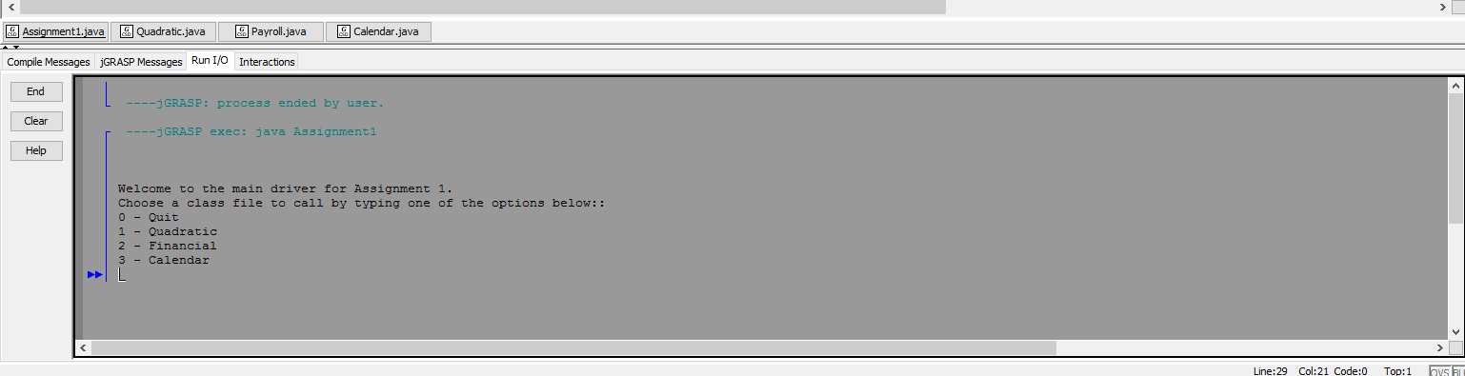

Quadratic.java

Sample 1

22

5

17

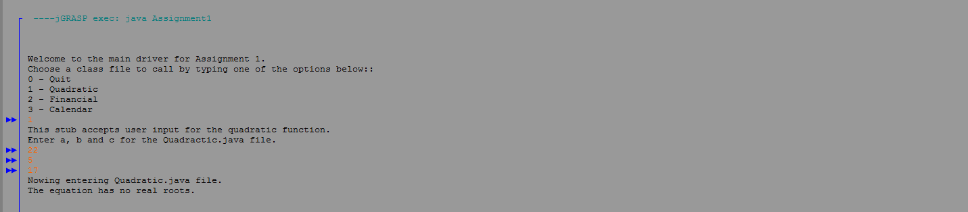

Sample 2

2

5

7

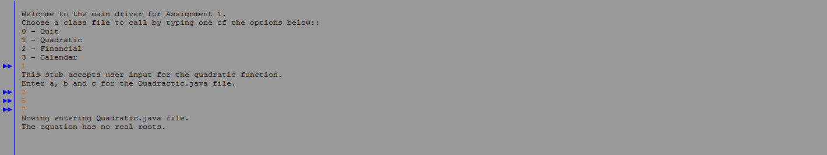

Payroll.java

Sample 1

John

15

22.50

.33

.1

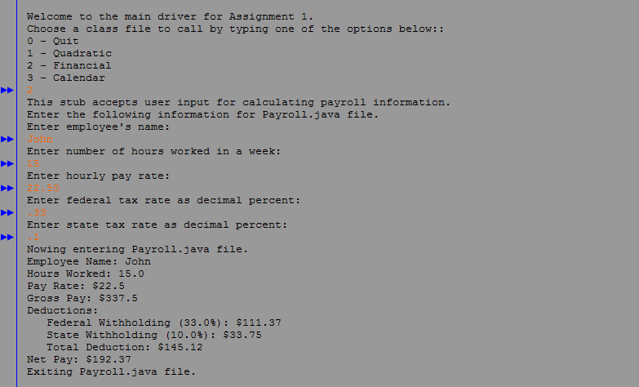

Sample 2

Tamy

20

35

.15

.01

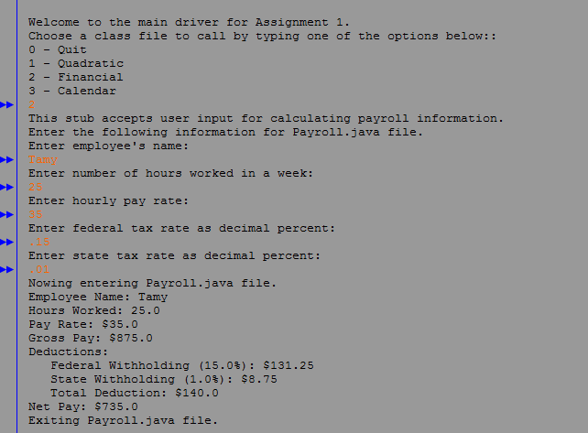

Sample 3

Sable

40

600

.37

.2

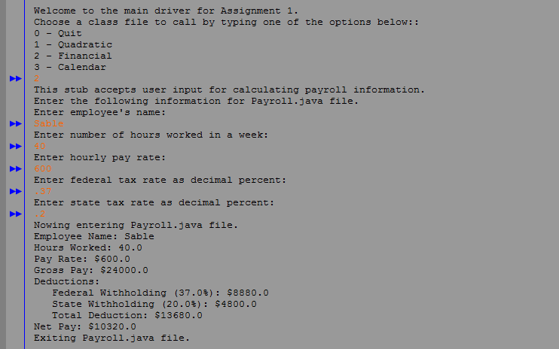

Calendar.java

Sample 1

2000

5

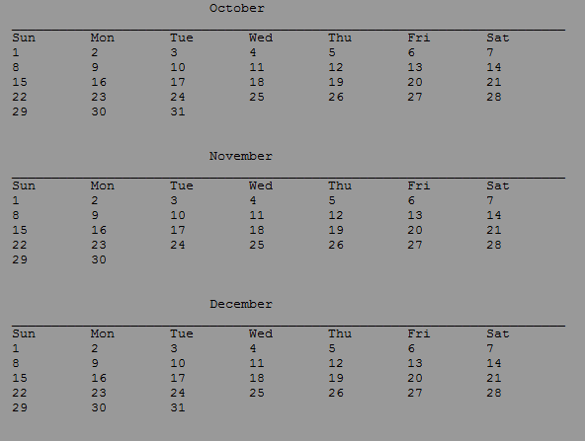

Sample 2

2500

8

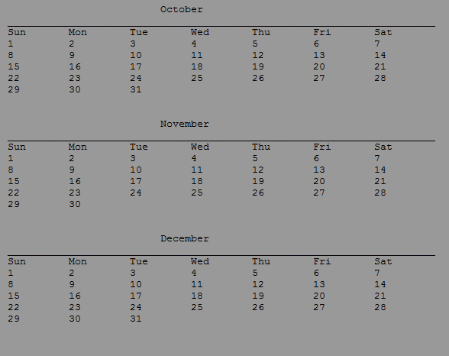

Sample 3

1992

3

